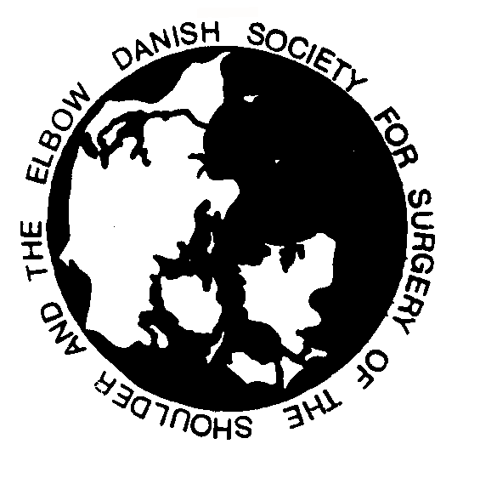

DANISH SOCIETY FOR SURGERY OF

THE SHOULDER AND THE ELBOW

Secretary:
Tim Houbo Pedersen
Dept. of Sports traumatology
Copenhagen University Hospital
Bispebjerg
Bispebjerg Bakke 23
DK 2400 Kbh NV
Houbo.tim@gmail.com

Indkaldelse til generalforsamling i Dansk
Selskab for Skulder & Albue Kirurgi.
Torsdag den 2. juni 2022 kl 17.00 – 18.00
Sted: Legenes Hus, Christiania Torv 5, Oslo

Dagsorden:
- Valg af dirigent.
- Godkendelse af referat fra seneste generalforsamling.
- Formandens beretning.
- Uddannelsesudvalgets beretning.
- Beretning fra skulderalloplastikregistret.
- Nye medlemmer og medlemsstatus.
- Forelæggelse af revideret regnskab til godkendelse.
- Fastlæggelse af kontingent.
- Valg til bestyrelse:
1 post på valg
- Nyt fra SECEC.
- Orientering om kommende møder.
- Evt.

President
Anne Kathrine Belling Sørensen
MD, PhD
Shoulder and Elbow section
Dept. of orthopedic Surgery
University of Copenhagen
KAS Herlev
Herlev Ringvej 75
DK 2730 Herlev

Vice President
Vacant

Treasurer
Jeppe V. Rasmussen
Shoulder and Elbow section
Dept. of orthopedic Surgery
University of Copenhagen
KAS Herlev
Herlev Ringvej 75
DK 2730 Herlev

Chairman Educational Committee
Mikkel Tøttrup
Shoulder and Elbow section
Dept of Orthopedic Surgery
Aalborg University Hospital
DK 9640 Farsø

Secretary
Tim Houbo Pedersen
Dept. of Sports traumatology
Copenhagen University Hospital
Bispebjerg
Bispebjerg Bakke 23
DK 2400 Kbh NV

YODA member
Liv Vesterby Knudsen

